NAME:S.MAHALAKSHMI
REG NO:192524372
COURSE: COMPLIER DESIGN
COURSE CODE: CSA1410
SLOT : D

PRACTICAL PROGRAMS (21 TO 40)

Exp. No. 21
Write a LEX specification file to take input C program from a .c file and count tthe number of characters, number of lines & number of words.
OUTPUT:
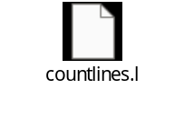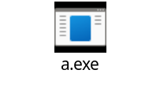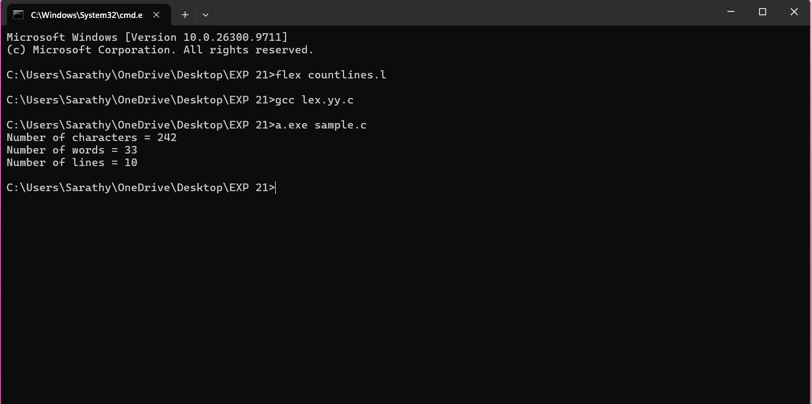
Exp. No. 22
Write a LEX program to print all the constants in the given C source program file
OUTPUT:
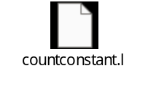
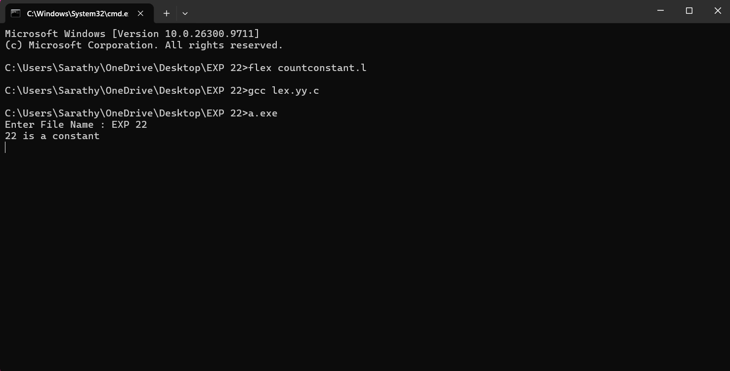

Exp. No. 23
Write a LEX program to count the number of Macros defined and header files included in the C program.

OUTPUT:
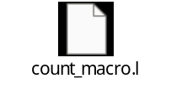

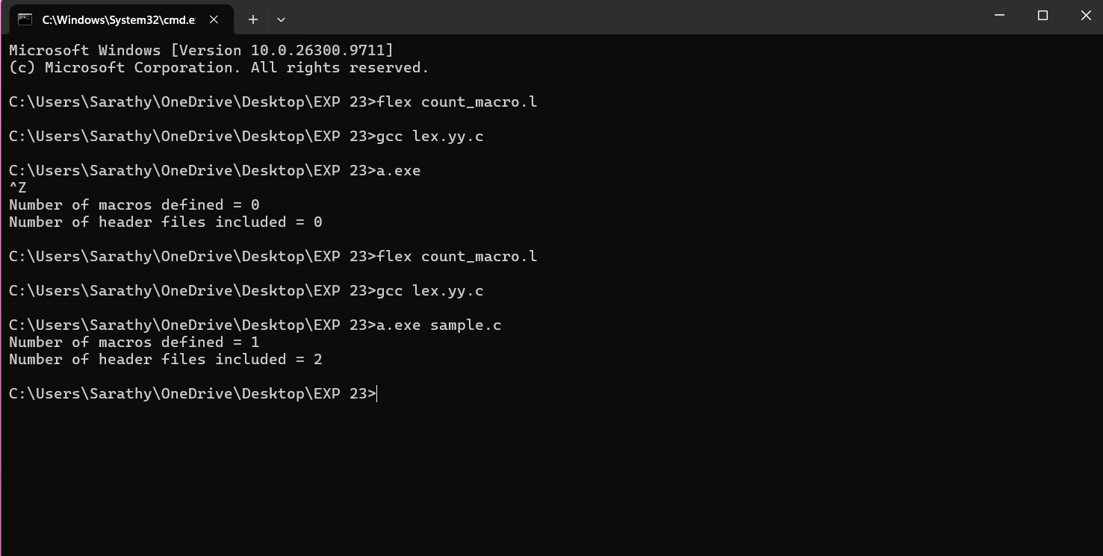

Exp. No. 24
Write a LEX program to print all HTML tags in the input file.
OUTPUT:


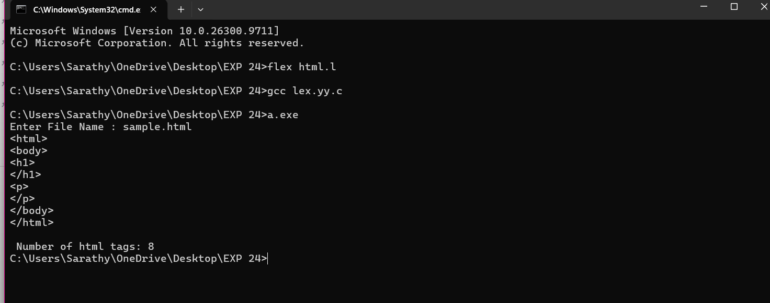
Exp. No. 25
Write a LEX program which adds line numbers to the given C program file and display the same in the standard output.
OUTPUT:
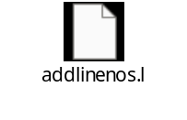
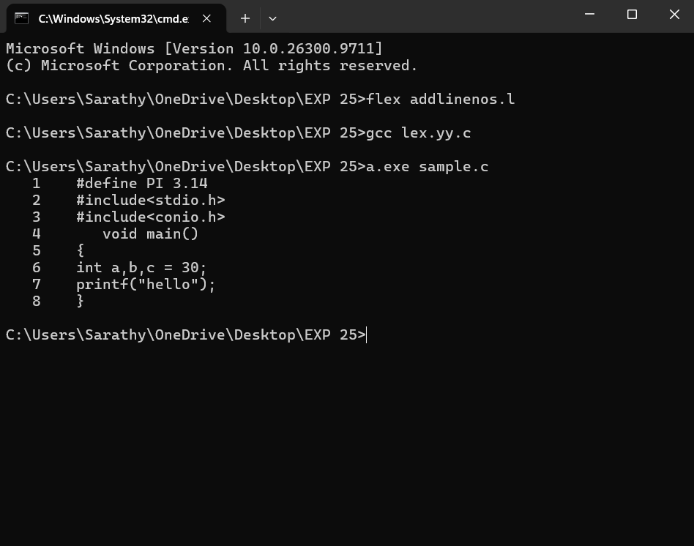
Exp. No. 26
Write a LEX program to count the number of comment lines in a given C program and eliminate them and write into another file.
OUTPUT:

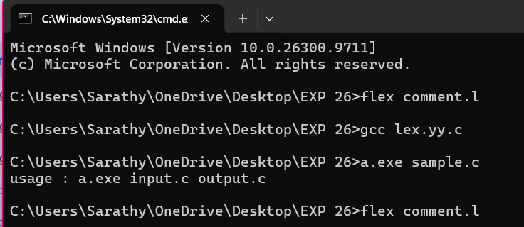

Exp. No. 27
Write a LEX program to identify the capital words from the given input.

OUTPUT:


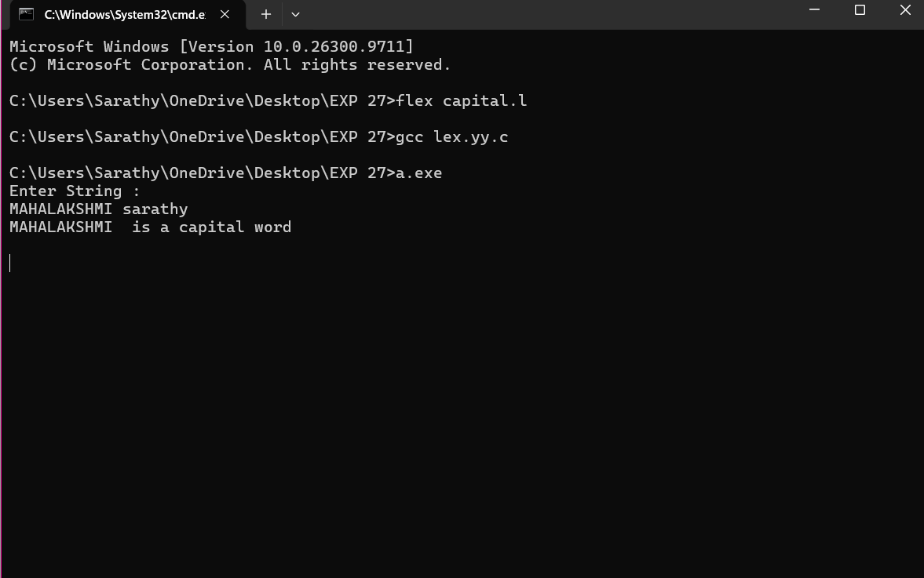
Exp. No. 28
Write a LEX Program to check the email address is valid or not.
OUTPUT:
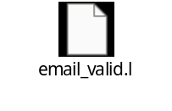

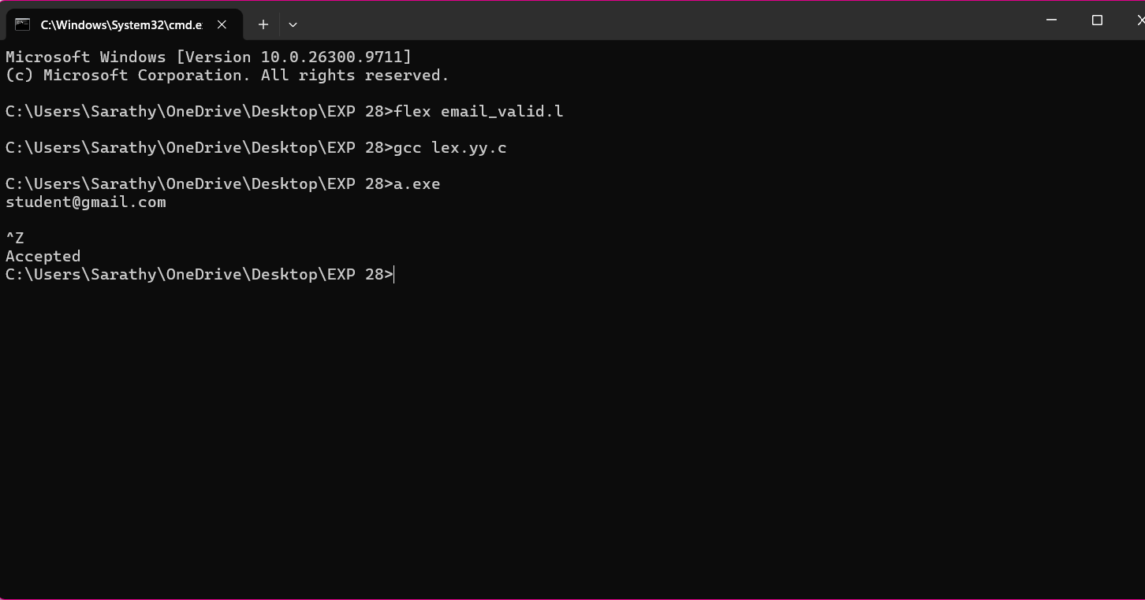

Exp. No. 29
Write a LEX Program to convert the substring abc to ABC from the given input string

OUTPUT:

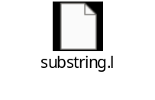

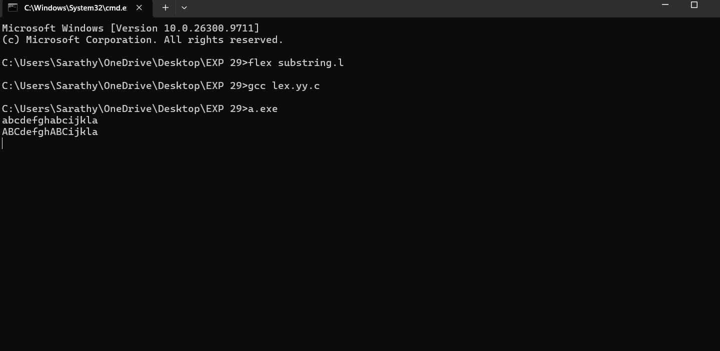

Exp. No. 30
Implement a LEX program to check whether the mobile number is valid or not.
OUTPUT:


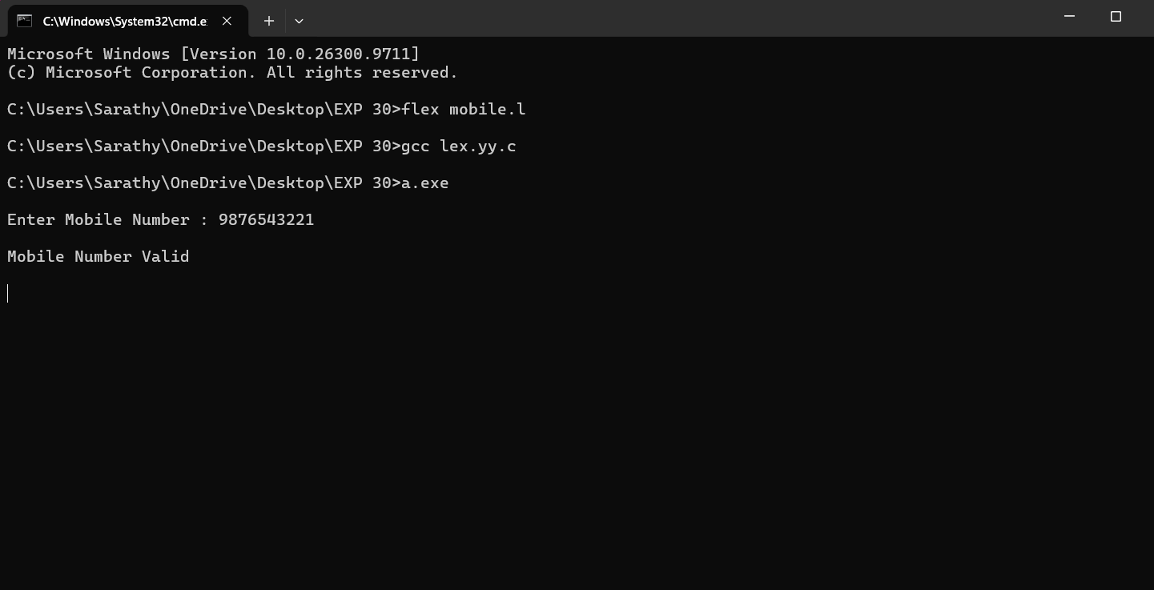

Exp. No. 31
Implement Lexical Analyzer using FLEX (Fast Lexical Analyzer). The program should separate the tokens in the given C program and display with appropriate caption.
OUTPUT:

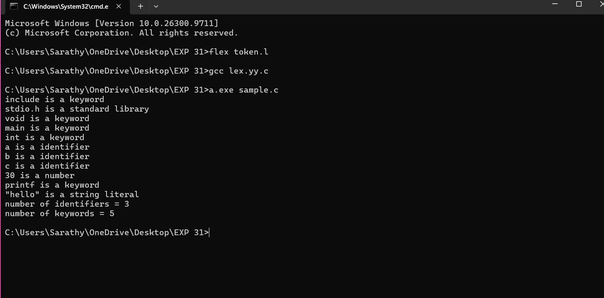
Exp. No. 32
Write a LEX program to count the number of vowels in the given sentence.
OUTPUT:
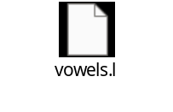

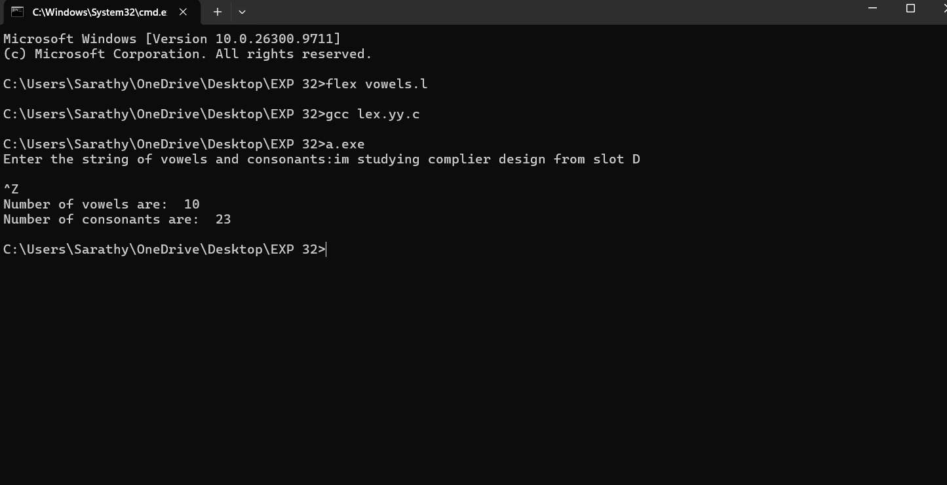

Exp. No. 33
Write a LEX program to count the number of vowels in the given sentence.
(Refer the program and output of experiment 32, both are same)
Exp. No. 34
Write a LEX program to separate the keywords and identifiers.
(Refer the program and output of experiment 31, both are same)

Exp. No. 35
Write a LEX program to recognise numbers and words in a statement.
OUTPUT:
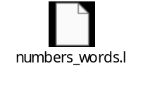
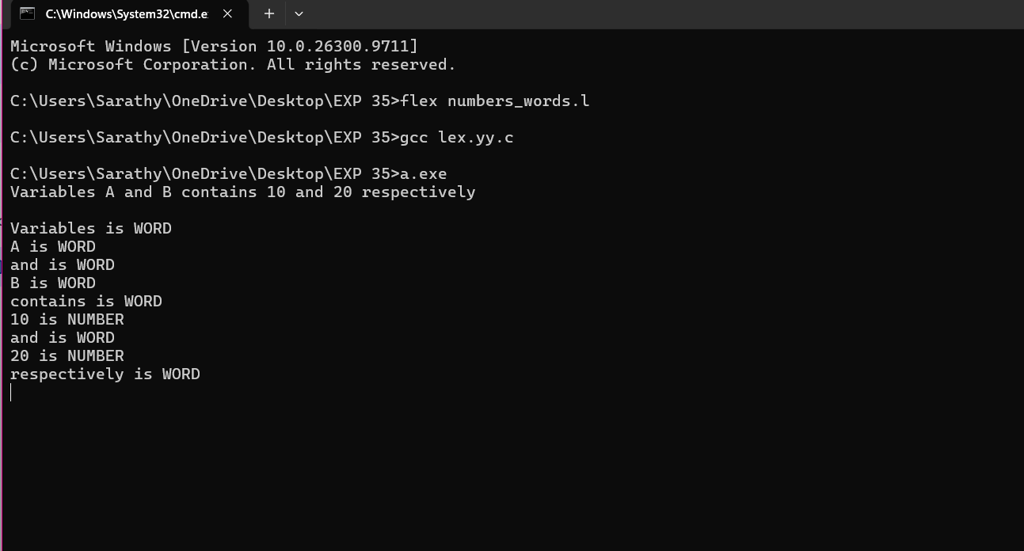

Exp. No. 36
Write a LEX program to identify and count positive and negative numbers.

OUTPUT:
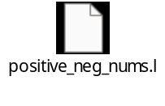

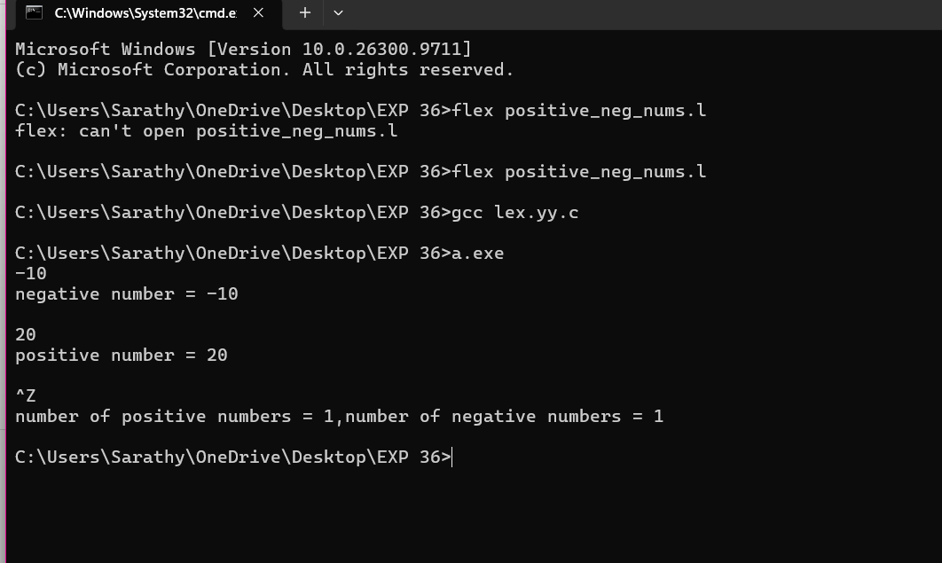

Exp. No. 37
Write a LEX program to validate the URL.
OUTPUT:
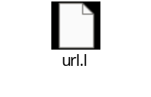
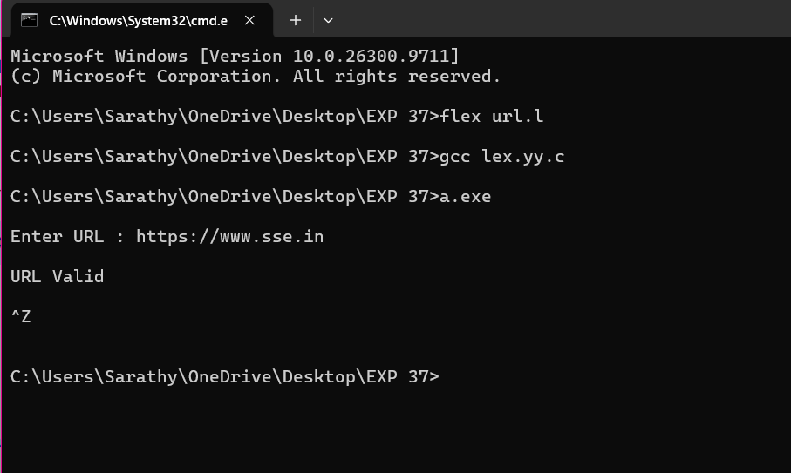
Exp. No. 38
Write a LEX program to validate DOB of students.
OUTPUT:
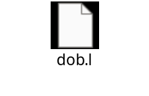

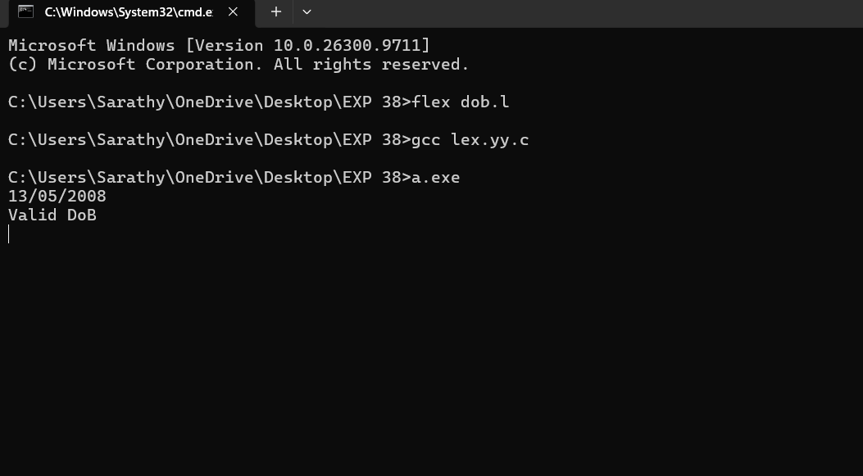

Exp. No. 39
Write a LEX program to check whether the given input is digit or not.
OUTPUT:
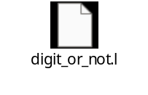
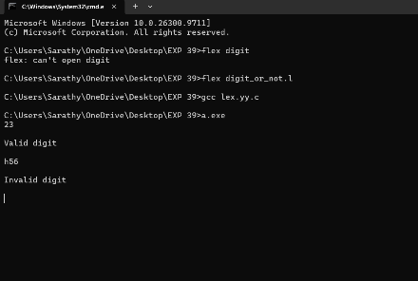
Exp. No. 40
Write a LEX program to implement basic mathematical operations.
OUTPUT:
